LAB 2 :

TOPICS : Strings, LIST and Tuple (10 marks)

**Assignment 5: Strings**

5.1 Predict the output :

a = "Python Programming!"

print(a[2:5])

print(a[1:8:3])

5.2

Write the Python statements to change the string “Java Programming” to “Python Programming” using

String operations.

5.3 Write a program to do this:

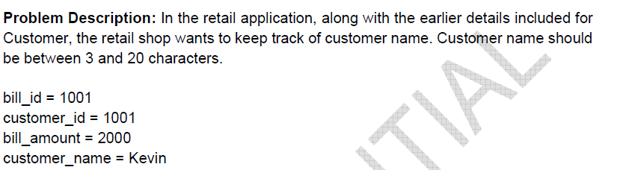

5.4 Write a program to remove all punctuation from the string provided by the user

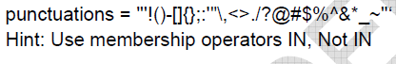

5.5

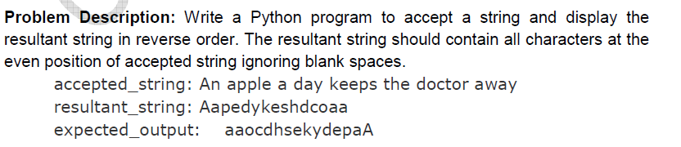

**Assignment 6: LISTS and TUPLES**

**6.1 Quiz**

**6.2 Find the difference:**

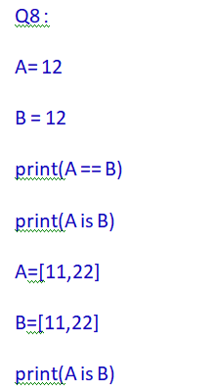

A=”Sample”

B=”Sample”

print(A is B)

**6.3 Change the above tuples (Qno 6.1)as list and find the output.**

**6.4 Is the program contains LIST or TUPLE ? Explain and proceed.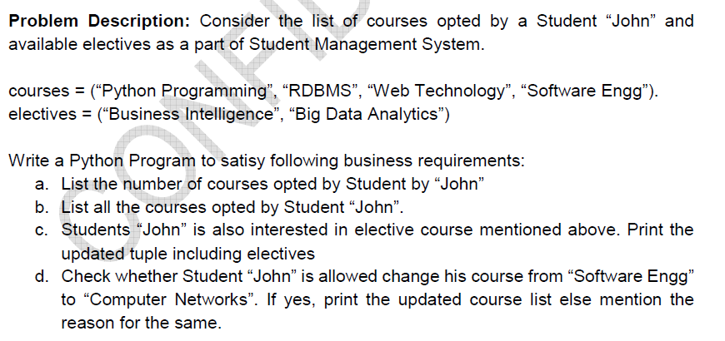6.5 Do you need a LIST or TUPLE for the below? Justify and proceed to implement**

**Problem Description :** You have a bundle of currency of varied denominations. Arrange them in descending order. Use appropriate data structure and algorithm to do this.